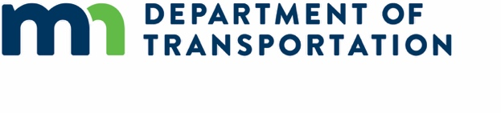
Minnesota Electric Vehicle Infrastructure Plan Overview
The federal Bipartisan Infrastructure Law (BIL) created the National Electric Vehicle Infrastructure (NEVI) Formula Program. The new program provides funds for states to install fast chargers for electric vehicles along designated corridors. The new program aims to provide reliable, long-distance EV travel, while also recognizing the unique needs of different regions and communities.
Initially, states must spend NEVI Formula Program funds to build out federally-designated Alternative Fuel Corridors (AFCs). Full build out includes installing fast chargers every 50 miles within 1 mile of the AFC and providing at least four 150kW direct current fast chargers that are capable of simultaneously charging 4 EVs. Once the state’s AFCs are fully built out, funding may be used on any public road or in other publicly accessible locations.
Minnesota will receive $68 million in federal funds from the NEVI Formula Program over five years. There is also a 20% non-federal match requirement ($17 million). Currently, there is not a state match for these funds, and it is likely the private sector will have to provide the match. MnDOT and other agencies continue to look creatively at this to try to identify state match, so that the state can have more input into the deployment.
The Minnesota Electric Vehicle Infrastructure Plan describes how Minnesota will spend the first year of NEVI Formula Program funds. The Minnesota Department of Transportation (MnDOT) developed this plan in coordination with the public and stakeholders throughout the state. MnDOT conducted engagement from April-June 2022, including virtual workshops with local utilities, EV installers, and local governments; presentations at approximately 60 different meetings to over 1,500 individuals representing nearly 1,000 organizations; a plan website; an online survey that was promoted via stakeholder emails and targeted social media ads; and four in-person community events in Minneapolis, Duluth, Albert Lea, and Fergus Falls.
The plan includes a vision and goals for a statewide fast charger network that provides convenient, reliable, and accessible EV charging across Minnesota. The plan identifies potential locations along Minnesota’s two existing Alternatives Fuel Corridors, Interstates 35 and 94, where the agency will initially work with third parties to install fast chargers.
The plan also describes implementation considerations related to operations and maintenance, civil rights, equity, labor and workforce, and cybersecurity. The plan concludes with information about how MnDOT will evaluate the NEVI Formula Program implementation in Minnesota.
It will take time and collaboration to achieve the vision of a convenient, reliable, affordable, and equitable charging experience throughout Minnesota. The first year of investment from the NEVI Formula Program will serve as a catalyst for future EV charging station deployment. Minnesota will update the plan annually and will identify additional corridors for investment based on technical analysis and stakeholder input.

